Book Your Doctor

Amiya Ranjan Rout   
*Department of Computer Science & Application*  
*College of Engineering and Technology*Bhubaneswar 751 003, India  
[arrout29@gmail.com](mailto:arrout29@gmail.com)

Pragya Parimita Panda  
*Department of Computer Science & Application*  
*College of Engineering and Technology*Bhubaneswar 751 003, India  
[paripragya18298@gmail.com](mailto:paripragya18298@gmail.com)

Manas Ranjan Parida  
*Department of Computer Science & Application*  
*College of Engineering and Technology*Bhubaneswar 751 003, India  
[manas83838@gmail.com](mailto:manas83838@gmail.com)

*Abstract*— **Now a day’s healthcare issue is one of the tough challenges for our country. For metro cities, smart cities, it's may not be a major issue but for small cities and especially for rural areas this issue is enhancing day by day because of the lack of experienced doctors. So, our main focus is to develop this project to reduce health care issues in those areas. We aim to develop an application that would act as a medium between Doctor and Patient. As we know some experienced doctors from bigger cities used to visit their private clinic or some pharmacies situated in small cities and the rural area once or more than once in a week. But people in their respective areas are unable to know about Doctor's availability. And even if they get to know the Doctor's availability, they are facing a lot of problems to get a ticket. E.g. they have to stand in queue from dawn to get an early ticket. Through our platform, our main target is to collaborate with those pharmacies and provides some better solution for this issue. This application will provide the availability of registered Doctors. And Patients can also search for doctors as per their specialty and book an appointment for the same. And if later on, they changed their mind they can also cancel the appointment.**

Keywords—Health Care Management, e Health Software, Android Application [1][2][3], Web Application [8], Search Doctors, Doctors Booking, Patients Record Management, Firebase [4], XML [7], JAVA [6], Android Studio [5], HTML [7], CSS [7], PHP [9], MySQL [10], Bracket, Sublime.

# **Introduction**

BookYourDoctor is more than an app for finding doctors.

Whether it's viewing doctors’ profile, booking doctor appointments, confirming appointments**,** cancelling appointments, BookYourDoctor helps you find online medical services & solutions to enable you to take better care of yourself. Briefly, the main goal of this project is: Finding the right doctors for your good health can be a challenge. With an expansive list of verified doctors, specialists, surgeons from neighborhood clinics & top hospitals to choose from, we help you get appointments with the doctors using the BookYourDoctor app.

# **goals and scopes of this project**

1)The system allows a doctor to add their details such as their name along with their designation, specialization, experiences and also with a brief description of them. 2)User can search for top experienced doctors as per their specialization. 3)User can search for top experienced doctors as per their nearby location. 4)User can find right doctors by viewing the doctor’s profile. 5)User can book an appointment with their specialized doctors. 6)User can see their all appointment letters at a one place. 7)User can also cancel their appointments.

# **literature survey/review of literature**

A literature review is a search and evaluation of the available literature in your given subject or chosen topic area. A lot of projects and researches has been done aiming in proper solving the problem of users.

Here is some related work of the book your doctor system.

*Online appointment Booking survey Reporting:*

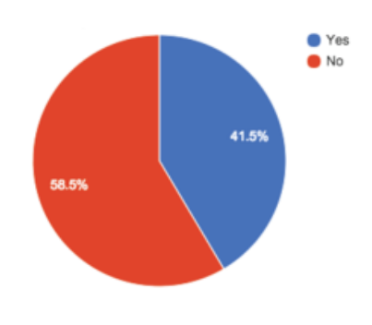Nearly half (42 percent) of survey respondents say they would like online appointment scheduling on the [healthcare website](https://www.patientpop.com/for/healthcare-website/), versus scheduling by calling the practice. However, only 17 percent of respondents said they currently have the option to schedule their appointment online.

Figure 1: Booking Survey Reporting

*Patient Pop Survey*: I would prefer to book an appointment with the doctor online with a website or mobile app without having to go to the clinic.

Given the chance to schedule online 24/7, about 34 percent of new patients were able to make an appointment outside of standard business hours.

*Patient Pop Data:* 34.4% of appointment scheduled online were scheduled during closing hours.

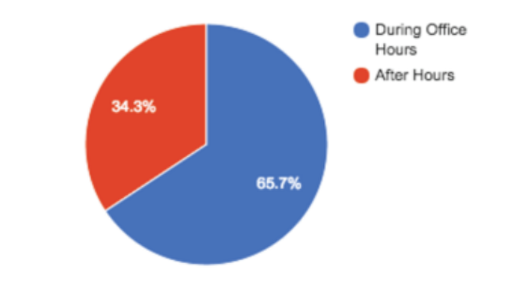

Figure 2: Survey Reporting on Patient Pop Data

When patients have access to schedule their appointment online, 26 percent are able to choose appointments the same day or the next day, filling empty slots.

Online scheduling allows patient to fill open same day and next day slots.

* 6% of appointment scheduled online are for the same day slots.
* 20% are of next day slots.
* 26% of appointment scheduled online were for same day or next day slots.

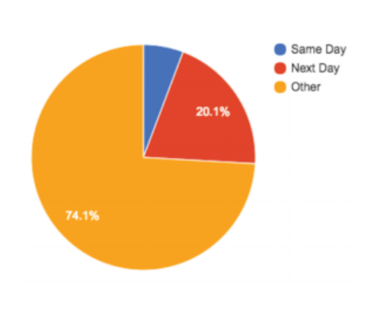

Figure 3: Survey Reporting on Patient Pop Data

# **EXISTING SYSTEM**

In the existing system it only working on metro cities and smart cities. Then what about for small town and especially for rural area? And also, it’s main focus on doctor’s private clinic which is very rare in rural areas.

The following are the drawbacks present in the existing system:

1. Only for smart cities and for metro cities.
2. No scope for small towns.
3. No scope for rural areas.
4. Only focus on doctor’s private clinic.

# **PROPOSED SYSTEM**

In the proposed system our main focus is to collaborate with those pharmacies in which some experienced doctors from bigger cities used to visit once or more than once in a week which are situated in small cities and rural areas. Our proposed system provides solution to existing system by extending its facilities as follows:

1. Extending the facility to the small-town areas.
2. Extending the facility to the rural areas as well.
3. Collaborating with pharmacies.

# **SYSTEM REQUIREMENT**

*For Android Platform:*

**Frontend**

Android Development Tools

XML

**Backend**

Advanced JAVA

Firebase

**IDE**

Android Studio

**Hardware Requirement**

**Application Requirement**

Android version 6.0 (Marshmallow onwards)

4GB RAM

1.2 GHZ Processor

**Development Environment Requirement**

Intel i3 5th Generation Processor

Windows 10 / UBUNTU 14.0.4

Android Studio Installed

*For Web Platform:*

**Frontend**

Web Development Tools

HTML, CSS

BOOTSTRAP

**Backend**

MySQL

PHP

**IDE**

Brackets, Sublime

**Development Environment Requirement**

Intel i3 5th Generation Processor

Windows 10 / UBUNTU 14.0.4

Brackets or Sublime Installed

# **SOFTWARE DESIGN**

In this section we define the scope of the design effort. The design phase is an important part of the system development phase. A good design of the system needs creativity and flair from the designer and is the key to effective and successful engineering. The following are the basic objectives of the software design process:

* To describe the process of software design where informal ideas are transformed into detailed implementation description.
* Introduction of different stages in the design process.
* Understanding whether an Object Oriented or a Functional Oriented approach or both should be applied to the software.
* Determining and improving, cohesion control and coupling within subsystems.

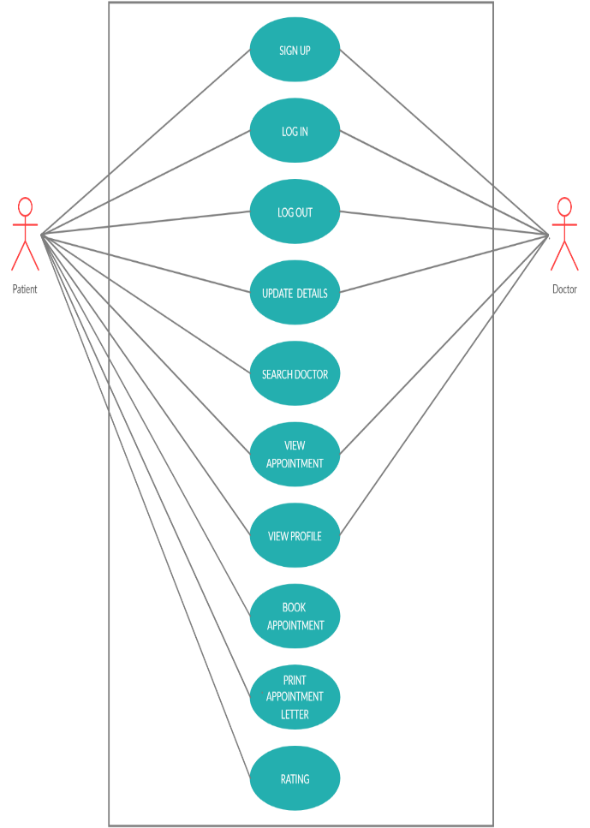

Figure 4: Use Case Diagram

# **ARCHITECTURAL DESIGN**

Large system is generally decomposed to smaller subsystems that account for functionality of the complete software system. This process of identifying the sub systems and establishing a framework for sub system control and communication is called architectural design. Architectural design is an important phase, as a bad architectural design cannot be rescued by good implementation. Following activities were performed during this stage:

* Principle sub systems that are functionally independent were identified and distinguished.
* A general model of control relationships between system parts was established.

Each subsystem was further decomposed into their sub function.

Register details

Figure 5: Architecture of BYD System

# **CODING**

<https://github.com/amiya559/BookYourDoctor>

# **RESULT/OUTPUT**

*For Android Platform:*

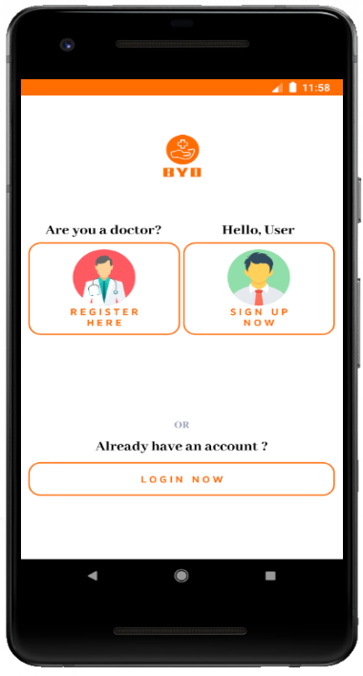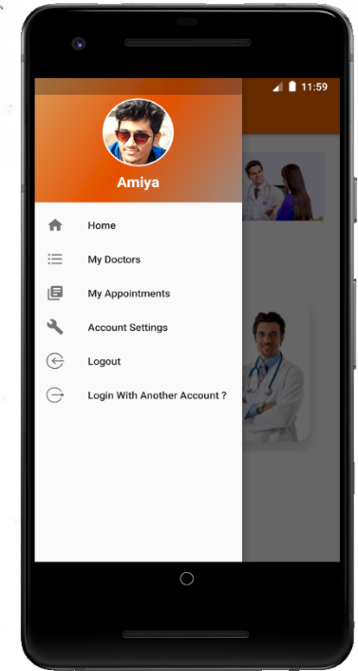

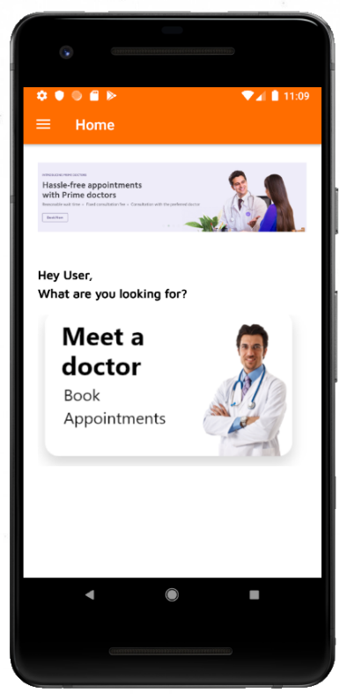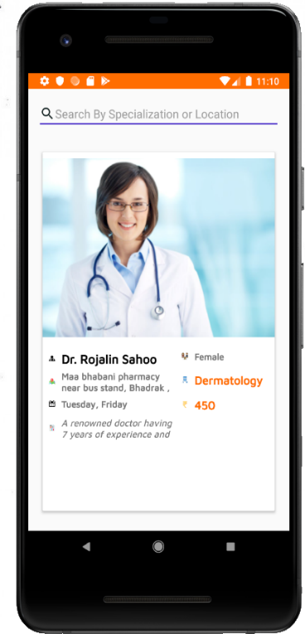

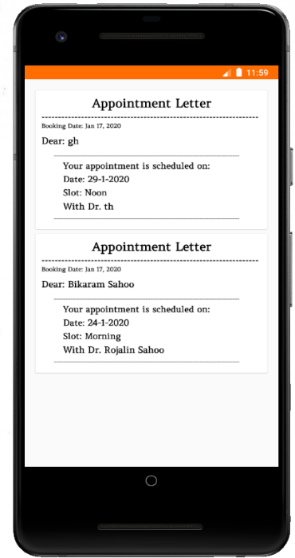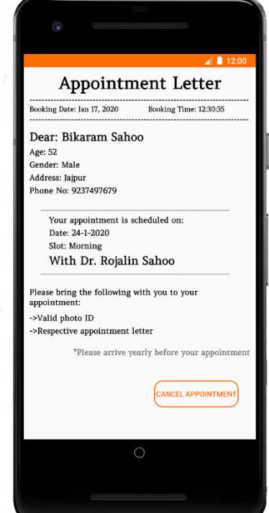

Figure 6: Output Screens for Android

*For Web Platform:*

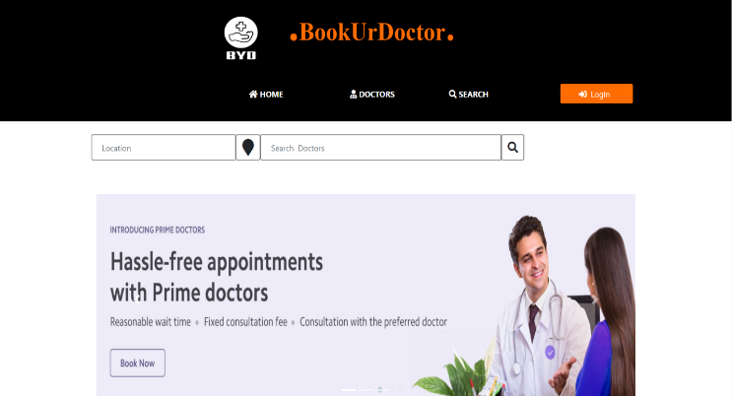

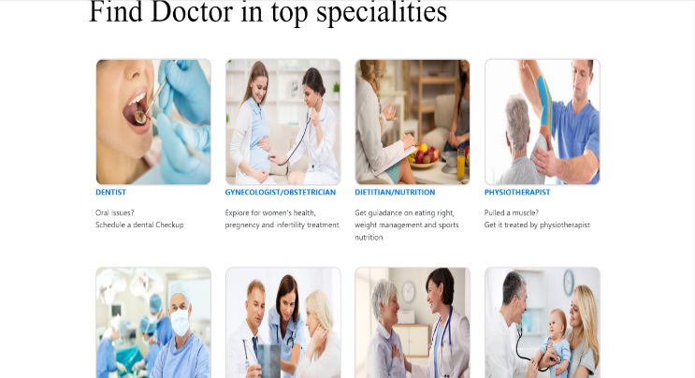

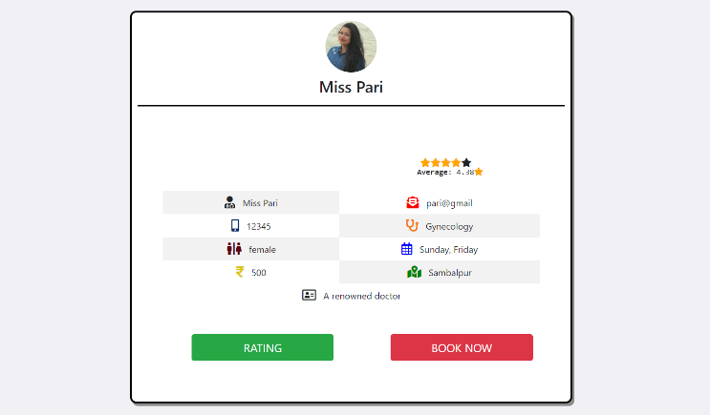

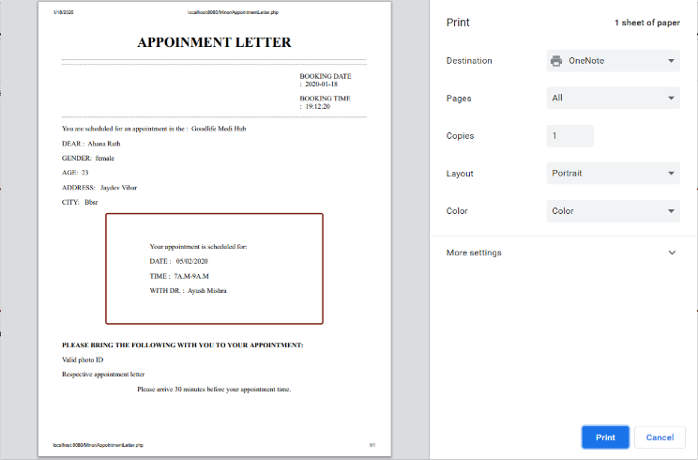

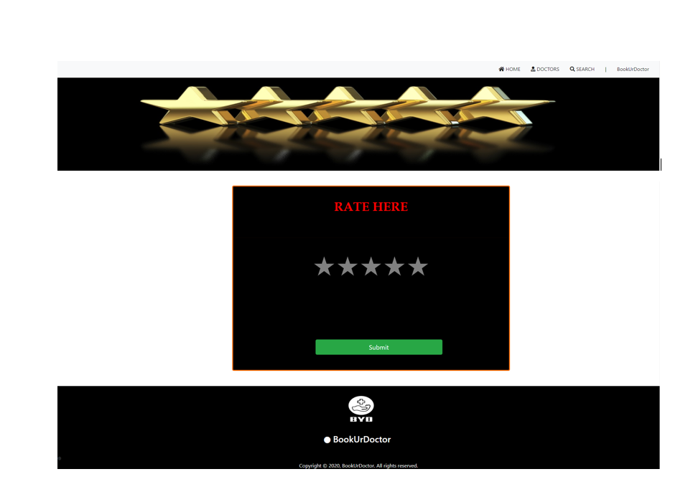

Figure 7: Output Screens for Web

# **CONCLUSION**

A health system, also sometimes referred to as health care system or healthcare system is the organization of people, institutions, and resources that deliver health care services to meet the health needs of target populations. For health checkups there are many Systems available such as thyrocare android app, Ewireless healthcare system, practo etc. So, taking in mind these apps were efficient for only specific health related issues. Thyrocare android app is only helpful for thyroid affected persons. E-wireless healthcare system is only helpful for maintaining data about particular hospital. Practo app is helpful for just obtaining the detailed information of doctors in metro cities and taking online appointments.

Hence to overcome all the drawbacks of the existing systems we are introducing and implementing the online healthcare system using both android and web platform which will be efficient for providing online booking facilities with discounted rates for the small town and rural area peoples.

Thus, our proposed system will be helpful in avoiding lots of hectic work such as:

1. Paper work

2. Time

3. Finding doctors at their nearby locations

It is not possible to develop a system that makes all the requirements of the user. User requirements keep changing as the system is being used. Some of the future enhancements that can be done to this system are:

* As the technology emerges, it is possible to upgrade the system and can be adaptable to desired environment.
* Because it is based on object-oriented design, any further changes can be easily adaptable.
* Based on the future security issues, security can be improved using emerging technologies.
* Payment gateway can be added.
* Prime membership can be added.
* GPS tracking can be implemented in order to track particular doctor’s location according to which the user book the appointment.

##### **Acknowledgment**

We are extremely grateful to **Professor Dr. Jibitesh Mishra, H.O.D** and as our Internal Guide, Department of CSA, College of Engineering & Technology for their encouragement and valuable guidance in bringing shape to this dissertation.

We will be failing in duty if we do not acknowledge with grateful thanks to the author of the references and other literature referred in this Project.

We express our thanks to all staff members and friends for all the help and coordination extended in bringing out this Project successfully in time.

Finally, we are very much thankful to our parents who guided us for every step.

##### **References**

1. <https://developer.android.com/>
2. <https://www.youtube.com/arsltech>
3. <https://drive.google.com/drive/folders/1-Iw0ZoHL5cnh6F4WPEddf2JP1hi3pUb8>
4. <https://firebase.google.com/docs/android/setup>
5. <https://developer.android.com/studio/install>
6. <https://www.geeksforgeeks.org/java/>
7. <https://www.w3schools.com/>
8. <https://in.udacity.com/courses/web>
9. <https://www.geeksforgeeks.org/php/>
10. <https://www.geeksforgeeks.org/sql-tutorial/>